**Assignment – 2**

• Connect to the Store Sales Data and do the following: -

− Remove all the blank rows.

− Update the column header if they are not updated

− Create a text table and show the sales in terms of Customers, Product Category and Regions.

Solution:

-Blank rows removed

-Column header updated

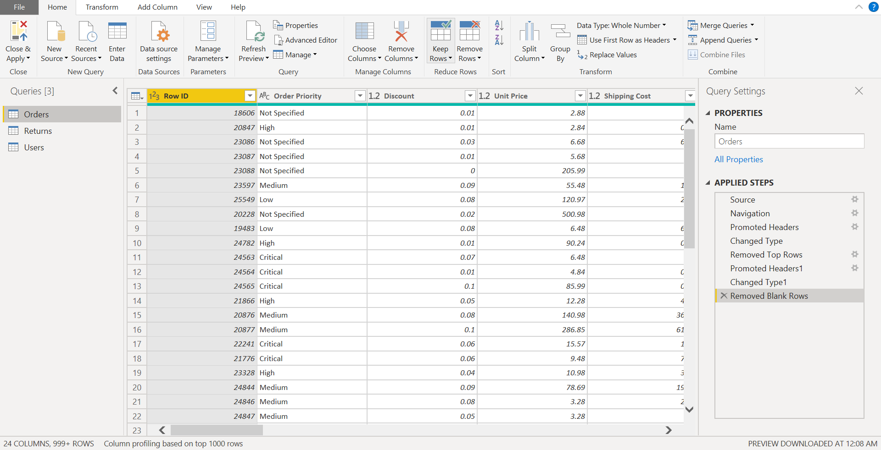

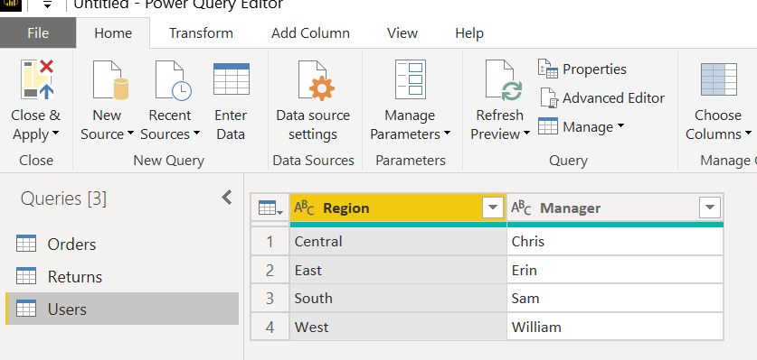

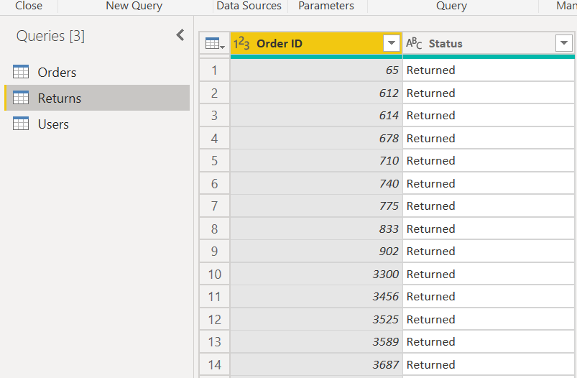

* Text table showing the sales in terms of Customers, Product Category and Regions.

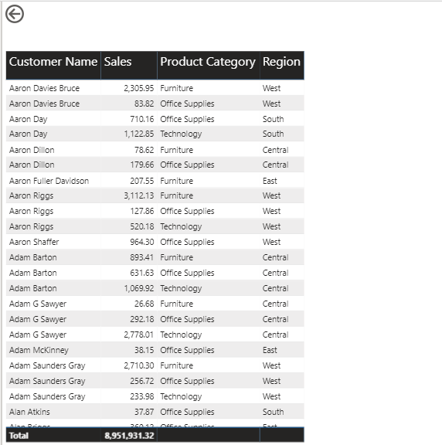

* Create a line and Clustered Column Chart showing the Sales and Discount as per the State or Province
  + Format the bars and line with different colors
  + Which state has the highest sales in terms Technology

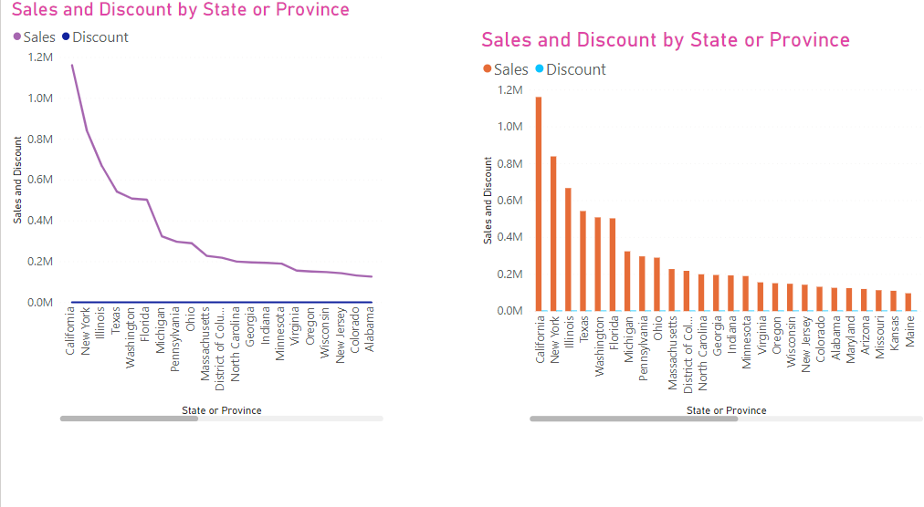

* Create a Donut Chart showing sales in terms of Product category

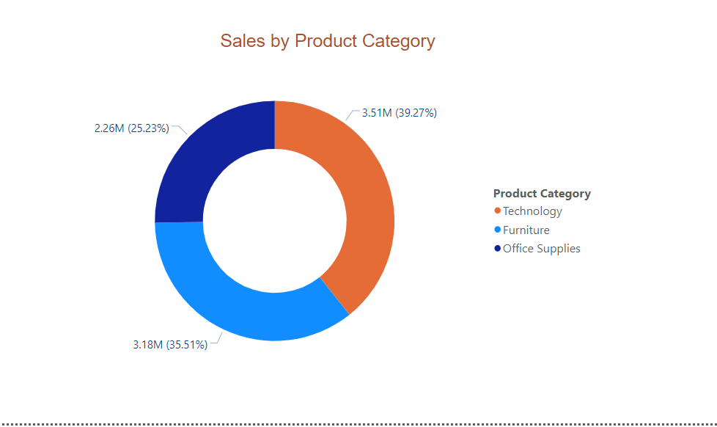

* Create a Slicer and show the regions in dropdown. See how all the visuals mentioned above behaving when a particular region is selected.

**Slicer with Donut chart and Text table**

* Central Region selected

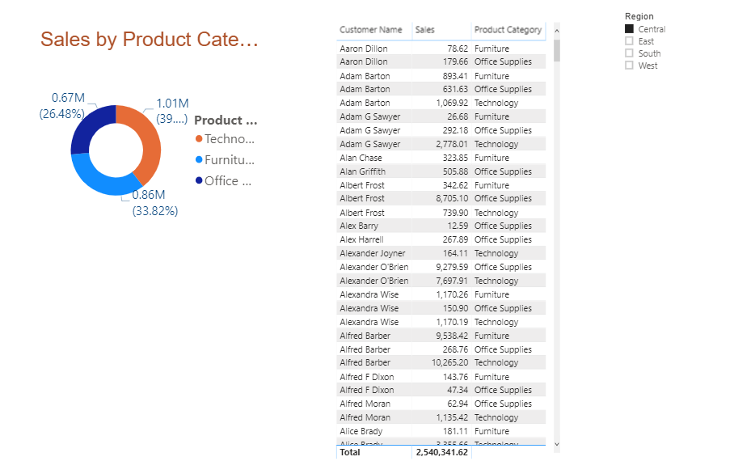

* South Region selected

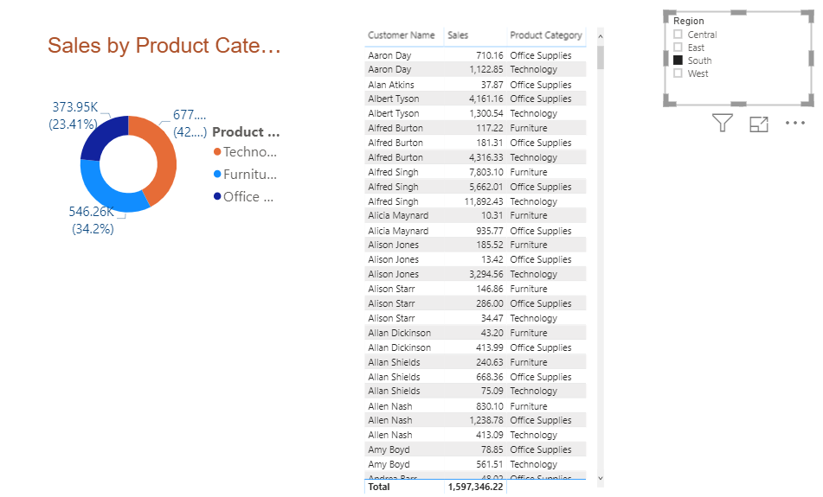

**Slicer with line and cluster charts**

Central Region selected

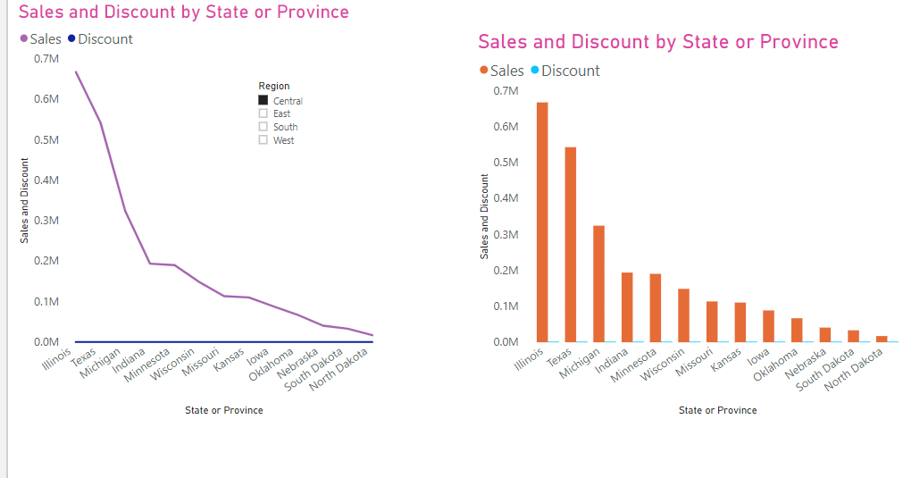

West Region selected

